**Predicting food insecurity using health and geographical metrics**

Ana Camargo Sandoval   
The Harold and Inge Marcus   
Department of Industrial and   
Manufacturing Engineering  
Penn State UniversityState College, United States  
avc6470@psu.edu  
  
Vinay Saji Mathew  
The Harold and Inge Marcus   
Department of Industrial and   
Manufacturing Engineering  
Penn State UniversityState College, United States  
vinaysmathew@psu.edu  
  
Jyotirmoy Nirupam Das  
The Harold and Inge Marcus   
Department of Industrial and   
Manufacturing Engineering  
Penn State UniversityState College, United States  
jfd5895@psu.edu

*Abstract*—Food insecurity has become a trending topic that has been investigated and analyzed using many different techniques. Previous research has shown that there is an association between food insecurity and several health metrics. However, to what extent could these health metrics estimate food insecurity is a different approach that is taken in this paper. The analysis is done for two main groups: adults and children, among all states and counties in the United States. As for the methodology, several machine learning techniques are used to conduct this analysis multivariable linear regression, random forests and logistic regression. Results showed that one can predict food insecurity rate with a root mean squared error of 0.015. Further, by dividing food insecurity into 7 levels one accurately predicts these levels with up to 90% accuracy. Along with this, our paper shows the mapping of food insecurity against various diseases across counties. These results prove our hypothesis that chronic diseases influences food insecurity.

Keywords—food insecurity, health metrics, machine learning, prediction model

# Introduction

Food insecurity can be defined as a lack of access to adequate nutritious food. Food security is quantified by a tedious process in which the Department of Agriculture (USDA) carries out a survey containing 18 questions which are filled by 45,000 households across America [1]. According to the number of affirmative answers to these questions, the households are separated into food insecure and food secure. Food insecurity can be due to several reasons. These reasons can be divided into three major sections: availability, access, and nutritious quality of the available food. Availability can be quantified by locating primary food sources such as farmers' markets, malls, or food banks. Further, the community's median income, poverty levels, and sociodemographic nature can help quantify access. It is difficult to quantify and avail data for the nutrient levels the population consumes; instead, we can quantify this using the different diseases among the different counties. Literature proves a strong correlation between ill health to food insecurity in communities.

Expanding on the idea of food insecurity due to the unavailability of food, we call an area a food desert if it is characterized by a lack of quality & quantity of food for its residents. This would also include a high cost of accessing nutritious food [2]. Studies indicate that urban neighborhoods which might not be thought of as food deserts also have areas where these exist. To classify food deserts, we must first identify the different products available in society and classify them as nutritious or problematic. This could be a problem since no single source is sufficient. In contrast, a combination of nutritious foods is generally considered a healthy diet.

One idea to solve food insecurity is through food aid. These services pretend to be a temporary way to help the most vulnerable food insecure population. One of the most important is food banks, which are large non-profit organizations that collect and distribute food/grocery items to hunger-relief charities [3]. Food banks act as food storage and distribution depots for smaller front-line agencies. As people are relying more and more on food banks as their primary source of food, it is of utmost importance to identify the role of these in regard to food insecurity. One of the biggest concerns is that food banks need to be able to improve food insecurity and supply their clients' nutritional needs. However, it is true that they can indeed reduce at some point food insecurity if appropriately managed. Nevertheless, several obstacles must be considered, such as the increasing demand for clients and donations not being sufficient and appropriate. To help food banks our machine learning model can help them locate high food insecurity areas using health data and thus helping them plan.

# problem definition and discussion

Food insecurity has been associated with poor health metrics. A critical part is first to identify which factors strongly correlate with food insecurity among the U.S. population. Also, to find a model that could estimate a potential food insecurity problem in the future based on the health metrics. From these predictors, the population's vulnerability to food insecurity could be determined at the state and county level.

All in all, this paper aims to identify critical health factors across the population and develop a prediction model at the state and county level. This model will help identify and predict the communities suffering from food insecurity or maybe food insecurity in the future.

# background literature

Several studies have linked health metrics of various age groups to food insecurity. Baiden et al. [4] investigated the relationship between adverse childhood experiences and food insecurity in US children from 0-5 years old. They analyzed data from the 2016–2017 National Survey of Children's Health using multinomial logistic regression (food insecurity as the outcome). Results showed a significant association between household food insecurity and several categorical variables considered in the analysis. The study by Thomas et al. [5] was to approximate what food insecurity causes children's health and healthcare usage. Using data from the National Health Interview Study (NHIS), they analyzed a broad range of child health outcomes aged from 2 to 17, using PS methods. As a result, they showed that food insecurity was related to significantly worse health (such as asthma, depression, skin allergies, and general usage of emergency rooms). Jackson et al. [6] studied the association between individual and cumulative adverse childhood experience exposure and food insecurity and parents' self-rated well-being. This was done by applying a multinomial logistic regression from the 2016 National Survey of Children's Health data. Higher odds of food insecurity were related to cumulative adverse childhood experiences, while the self-rated well-being of parents significantly influenced these associations. Drennen et al. [7] provided a relationship between food insecurity and health in children under four years old, such as obesity, underweight, stunting, health, and development. A multivariable logistic regression analysis was applied to data from a cross-sectional survey at medical centers. Findings revealed that food insecurity is associated with increased odds of fair or poor health.

Jih et al. [8] analyzed the effect of chronic diseases on older adults. They hypothesized that out-of-pocket healthcare expenditures might lead to a shortage of funds, inevitably affecting their buying capacity. They performed a statistical analysis to validate the hypothesis. The study was done on respondents from the 2013 Health and Retirement Study (HRS) Health Care and Nutrition Study. They categorized the chronic conditions from 0 to 5 and above. The results showed a heavy prevalence of food insecurity in older adults with multiple chronic conditions; hence additional attention should be given to chronic diseases while studying food insecurity. Jackson et al. [9] explored the relationship between physical limitations in older adults to food insecurity. The data was from a survey in which they asked the participants about the difficulty of performing 19 types of activities. Multinomial and logistic regression was used to determine the relationship between the survey results to food insecurity. Results showed that physical functioning is critical while screening older adults for food insecurity. S. L. Goldberg and B. E. Mawn [10] examined the National Health and Nutrition Examination Survey to study food insecurity from a social-ecological perspective. The variable was analyzed statistically, and a logistic regression analysis was performed. The critical factors for food insecurity in older adults are the severity of depression, financial background, and did they ever receive household food stamps benefits, Vilar-Compte et al. [11] provide a literature review on the various food insecurity measures, and they also assessed experience-based food security scales using psychometric analysis. They concluded that food security could be strengthened by producing valid monitoring instruments. These instruments should be taken into consideration the ecological and multisectoral information. J. S. Lee [12] showcased how data can be efficiently extracted and linked through various datasets from food insecurity and healthcare perspective. They linked the state aging services client database and the Centers for Medicare and Medicaid Services data to better estimate the healthcare cost, especially for food-insecure older adults with chronic devices.

K. L. Hanson and L. M. Connor [13] provided a comprehensive review of literature in which they found a strong association between food insecure adults consuming lower quantities of fruit, vegetables, and dairy products leading to a lower intake of vitamins A and B-6, calcium, magnesium, and zinc. The authors also concluded a strong association of insecurity with dietary quality, particularly the products mentioned earlier. Walker et al. [14] studied the relationship between food insecurity and mortality by matching national death index information with national health and nutritional examination. When looking at the food insecure population, there was a 49% higher mortality rate when demographics were adjusted. Despite adjusting for comorbidities, the hazard rate remained significant. A survey of the urban population of adults in Chicago, a cross-sectional population, showed that factors like loneliness, emergency food use benefits, and food stamps are significantly related to food insecurity. The study also showed an association with language factors and that the English-speaking population was food secure and concluded a strong correlation between food insecurity and social risks. The study used multivariate logistic regression with backward selection to build the model Hunt et al. [15]. Christian A. Gregory and Alisha Coleman-Jensen [16] analyzed the correlation between food insecurity and chronic health conditions among working adults and found a substantial likelihood of hypertension, coronary heart disease (CHD), hepatitis, stroke, cancer, asthma, diabetes, arthritis, chronic obstructive pulmonary disease (COPD), and kidney disease. The study also showed that food insecurity was a better predictor of these chronic diseases than income showing statistically significant differences in these diseases when comparing food-secure and insecure households. The literature review provides strong evidence linking health metrics and food insecurity across different health groups. Table I provide a brief summary on all the papers in the literature review.

TABLE I.

Summary of the literaure review

|  |  |  |  |  |
| --- | --- | --- | --- | --- |
| Paper | Metrics | Methodology | Data sources | Age group |
| Hunt et al. (2019) [15] | Social Risk (Use of food stamps or emergency food use), First Language (English not being primary language has higher odds of insecurity), Mental Health | Multivariate logistic regression with manual backward selection process | Sinai Community Health Survey 2.0 | 18 and over |
| Christian A. Gregory and Alisha Coleman-Jensen (2017) [16] | Most Chronic Diseases. (Hypertension, CHD, Hepatitis, stroke etc) | Logistic regression for association between food insecurity and chronic conditions | National Health Interview Survey | 18-64 |
| Walker et al. (2019) [14] | All causes mortality | Cox proportional hazards model | National Health and Nutrition Examination Survey and National Death Index information | 20 and over |
| K. L. Hanson and L. M. Connor (2014) [13] | Consumption of Vegetables, fruits and dairy | Systematic review of literature to find association of factors | Data gathered from literature survey | 18 and over |
| Baiden et al. (2021) [4] | ACE score (number of ACE: 0, 1, 2+), Primary caregiver’s level of education, Poverty level, Receipt of food assistance, Self-rated physical/mental health of primary caregiver | Multinomial logistic regression, food insecurity as the response variable. | National Survey of Children’s Health | 0-5 |
| Jackson et al. (2019) [6] | Cumulative ACEs (1, 2, 3+), Individual ACEs | Multinomial logistic regression, food insecurity and ACEs association | National Survey of children's Health | - |
| Drennen et al. (2019) [7] | Associated: child health and developmental risk reported by a caregiver, Not associated: obesity, underweight, stunting. | Multivariable logistic regression | Household Food Security Survey Module | 0-4 |
| Thomas et al. (2019) [5] | General health: scale from 1  (poor) to 5 (excellent), Chronic health (asthma, diabetes), Acute health (respiratory or stomach problems)  Healthcare access | Inverse probability of treatment weighting, to get the relation between food insecurity and these factors. | National Health Interview Study (NHIS) | 2-17 |
| Jih et al. (2018) [8] | Hypertension, Diabetes, Depression, Vision impairment, significant pain | Multivariate logistic model | 2013 Health and Retirement Study (HRS), Health Care and Nutrition Study (HCNS) | Above 50 years old |
| Jackson et al. (2019) [9] | Instrumental Activities of Daily Living, Leisure and Social Activities. General Physical Activities | Multinomial and logistic regression models | National Health and Nutrition Examination Survey (2007–2012) | Above 60 years old |
| S. L. Goldberg and B. E. Mawn (2015) [10] | Financial conditions, Depression, Demography | Statistical modeling and logistic regression | National Health and Nutrition Examination Survey (NHANES) | Above 60 years old |
| Vilar-Compte et al. (2017) [11] | ­ | A literature how food security measures relate to policies |  | Above 60 years old |
| J. S. Lee (2013) [12] | Health cost burden | Linking national datasets to local and state datasets | State aging services client database and the Centers for Medicare, Medicaid Services data | Above 60 years old |

# data description

From our initial discussion, we separated our population into three segments based on age and investigated various factors correlated to food insecurity within these segments. However, obtaining reliable data sources to separate adults and older adults incorporated too many errors in our data set. To prevent this, we focused on the county-level food insecurity rates only for adults and children, which were obtained from Feeding America (FA) [25]. FA explains in their technical brief that they source the data from the Current Population Survey (CPS) and the US Department of Agriculture to produce accurate measures for food insecurity, cost per meal, and average food budget shortfall in each state for every year. The cost per meal is derived by using the average amount spent per week by food secure individuals and dividing it by 21 (3 meals per day, seven days a week). The food budget shortfall is an annualized measure of the gap in resources for the people who are food insecure and is calculated at an individual level using the CPS data and then generalized over the population of that county. Equation 1 gives the calculation for the food budget shortfall.

$FBS=FIP ×17.25 ×52×7/12$ (1)

FBS is Food Budget Shortfall, and FIP is the number of Food Insecure Persons. This is based on evidence that, generally, food insecurity is prevalent on average for seven months a year. As reported by the USDA, $17.25 is the average food budget shortfall for a food-insecure person. Furthermore, the Centre for Medicare & Medicaid Services also maintains a database containing the prevalence of 21 chronic conditions by state, listed in Table 2 [26]. For our study, we matched the prevalence of these diseases by state with the data obtained from FA during 2016- 2020. This data is name DATA 1 primarily concerning adults.

TABLE II.

HEALTH FACTORS CONSIDERED FOR ADULTS

|  |  |  |  |  |
| --- | --- | --- | --- | --- |
| Alcohol Abuse | Ischemic Heart Disease | Schizophre-nia | Hyperlipidemia | Asthma |
| Arthritis | Autism Spectrum Disorders | Heart Failure | Hypertension | Diabetes |
| Depression | HIV | Hepatitis | Alzheimer | Cancer |
| Drug Abuse | Chronic Kidney Disease | Atrial Fibrillation | Osteoporosis | Stroke |

The children’s data used for this analysis was obtained from the National Survey of Children’s Health (NSHC), years 2016 to 2020 [27] named as DATA 2. The NSHC has been conducted nationwide by the US Census Bureau yearly since 2016. This survey collects data from children aged 0 to 17 years old, but also about their parents/caregivers and household. For more information about guides, survey instruments, methodology, and others, refer to [28].

For the explanatory variables (identified from the literature review), the selection was made based on their objectiveness due to the subjective nature of some of the responses. For instance, being asked about age or income level is more objective than being asked about self-perception. Therefore, selected factors were the age of the parent/caregiver, adverse childhood experiences (ACE), household poverty level, and receiving cash/food assistance. The age variable is the only one being used as an average, whereas all the others correspond to a proportion from the sample at the state level. ACE was used as the % having at least one ACE. The poverty level shows a % that is below 100% FPL [29]. Receive cash/food assistance refers to the % that does receive it. For the health metrics, it was used a similar approach as for the explanatory variables. From the survey, we selected these variables: allergies, arthritis, heart condition, frequent/severe headaches, asthma, diabetes, anxiety, and depression. The data was used at the state level as the proportion of the sample which suffers from these health conditions.

Hence, we have two datasets: DATA 1 belonging to adults and DATA 2 for food insecurity in children. Both datasets contain data from 2016 to 2020, DATA 1 at the county level and DATA 2 at the state level (county-level data is not available, a difficulty for our analysis of the children population. Only available food insecurity at the county level). The final analysis is done on the extension of Data 1 spanning all the counties from 2014 and 2018.

# methods

Initially, we analyzed the data with respect to its correlation with food insecurity. In the data processing part any variable that has a negative correlation with food insecurity has been removed. Machine learning algorithms are then used to analyze the data at two levels one being state and another being county. For any missing values, a mean imputer algorithm has been used. To create a prediction model two approaches have been explored. One is calculating a continuous dependent variable given as the food insecurity rate. Being a continuous variable it might be difficult to make policies on such a variable type. Hence, the next thing we tried is clustering the food insecurity rates at different levels. Since normal clustering algorithms would fail due to the time series nature of the data. We created artificial clusters by dividing the food insecurity rate by 7 and creating 7 clusters. 7 levles were chosen since this gave the most balanced dataset. For the first approach since most of our data is continuous, the method of analysis used comprised implementing multiple linear regression and random forest models to our data. Since we seek to understand the relationships between the parameters, interpretability is essential in understanding the contribution of individual predictors. This would further elicit importance when helping to shape policy for policymakers. Hence, multiple linear regression helped fit this aspect of the project. Furthermore, since the number of predictors used to build the model is large, a random forest approach was also chosen to help because of its high versatility. Furthermore, some of the data were broken for certain counties and contained missing values. A random forest approach’s robustness greatly helps in handling such unbalanced data. For the clustering approach as earlier stated we created an ordinal scale of food insecurity levels artificially. To map the metrics we then used Logistic Regression and a Random Forest Classifier to get the relationship between different levels and the health metrics. To sum up, we used two approaches to predict food insecurity for the first approach the dependent variable is a continuous food insecurity rate and for the second it is an ordinal variable created from the food insecurity rate.

# state-level results

Results from the Multiple regression model from the state level analysis are shown in Fig 2. and Fig 3. for children and adults respectively. The computation was done on Python 3.5 using Google Collaboratory, sklearn, pandas, and numpy libraries Furthermore, Table III shows a summary of how well the data fit these parameters. There is a huge improvement when we include the state name variable. Lasso works the worst in terms of regularization since an alpha of even 0.01 reduces the R-squared value whereas a careful selection of ridge regression keeps the R-squared value in the same range. Table III shows the result from dataset 1 and 2 and similar observations can be seen for the state variable. In both data sets, we achieve a high R-squared model showing the effectiveness of the linear regression model. The coefficients of variables after running multiple linear regression and backward variable selection are well explained in Fig 2. it can be seen that the age of parents, adverse childhood experiences (ACE), food assistance, and mental health problems are the key factors contributing to child insecurity. Similarly, from Fig. 3. drug abuse and disease which restrict physical limitations are causes of food insecurity in adults. Hence a prediction model can be formed using these health metrics. The dominance of the state name variable can be due to the fact of a short timeline or there is a need to explore more variables that explain food insecurity with more clarity other than the current health metrics.

TABLE III

R-squared value for different regression variables

|  |  |  |  |
| --- | --- | --- | --- |
|  | **Without State Name variable** | | |
| Data | Linear regression | Ridge (alpha=5) | Lasso (alpha=0.001) |
| DATA 1 | 0.61 | 0.46 | 0.435 |
| DATA 2 | 0.69 | 0.69 | 0.515 |
|  | **With State Name variable** | | |
| Data | Linear regression | Ridge (alpha=5) | Lasso (alpha=0.001) |
| DATA 1 | 0.974 | 0.72 | 0.43 |
| DATA 2 | 0.88 | 0.88 | 0.52 |

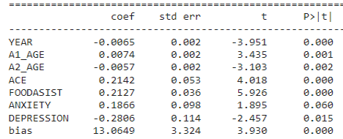

Fig. 2 Coefficients for Food Insecurity rate in children

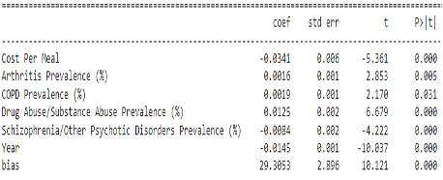

Fig. 3 Coefficients for Food Insecurity rate in adults

# county-level results

For this analysis, we considered a dataset of only adults for all the counties in the United States and data is 4-year data from 2014 to 2018. Initially, we ran a multiple linear regression model and calculated the p-values to get the important variables but our analysis showed all the health metrics as important. To get the important variables we took the variable with shap values greater than 0.004 as can be seen in Fig 4. marked in the red box. Once we fixed the health metrics we ran Multiple Linear Regression (MLR) and Random Forest Regressor (RFR) using the sklearn library to predict the food insecurity rate in each county. The Table IV. shows the different root mean square values and adjusted R-squared for the two algorithms. Additionally, we suspected a geographical factor in predicting food insecurity, and hence adding state or county data improves the result. We get a minimum RMSE of 0.015 when we use MLR on the data which has the county variable. This concludes that geography and health parameters influence food insecurity. Though RFR gives a better R-squared we chose MLR due to the lower RMSE and has higher interpretability.

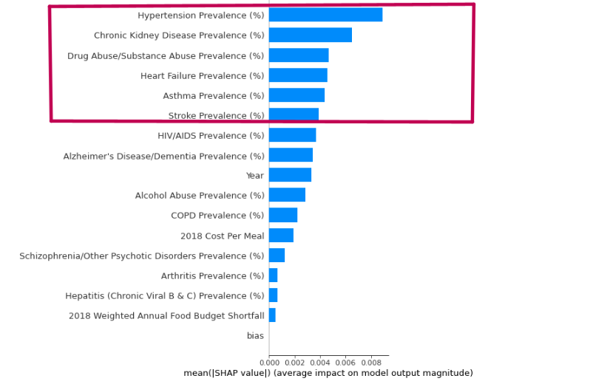

Fig 4. Shap values of health variables

Table IV

Results on county level data using regression

|  |  |  |  |  |  |  |
| --- | --- | --- | --- | --- | --- | --- |
|  | MLR | | | RFR | | |
|  | Health data | with state | with county | Health data | with state | with county |
| RMSE | 0.0365 | 0.0305 | 0.015 | 0.0328 | 0.025 | 0.029 |
| R-squared | 0.227 | 0.47 | 0.927 | 0.91 | 0.94 | 0.93 |

For the second approach as discussed in the methodology section Logistic Regression (LR) and Random Forest Classification (RFC) have been used. Table V. and Fig 5. show the classification accuracy and here too logistic regression outperforms RFC and has higher interpretability. Additionally, if we include the train data we get a 90% overall accuracy which can be useful to classify counties at a broader level and help in making robust policies targeting regions and diseases. To further explore this we mapped the correlation of diseases with food insecurity at the county level for 5 states with high populations. Fig 6. shows the maximum correlated variable for each county against food insecurity. It can be seen similar diseases affect neighboring counties. Thus if one targets these epidemics which spread across a few counties one can have higher food security. This analysis has been done from the perspective of food insecurity hence the disease highlighted in each county influences food insecurity. There can be other epidemics in a region our map shows the disease which may be responsible for higher food insecurity.

Table V

Results on county-level data using classification

|  |  |  |
| --- | --- | --- |
|  | LR | RFC |
| Health data | 0.57 | 0.61 |
| with state | 0.65 | 0.7 |
| with county | 0.83 | 0.71 |

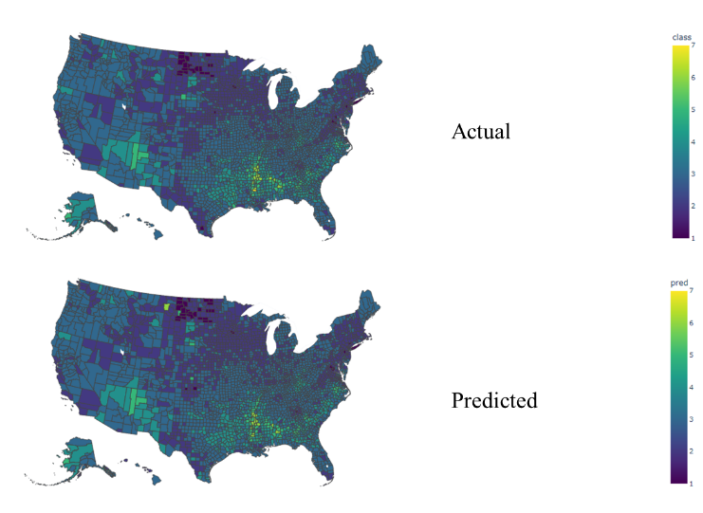

Fig 5. Classification results on the map

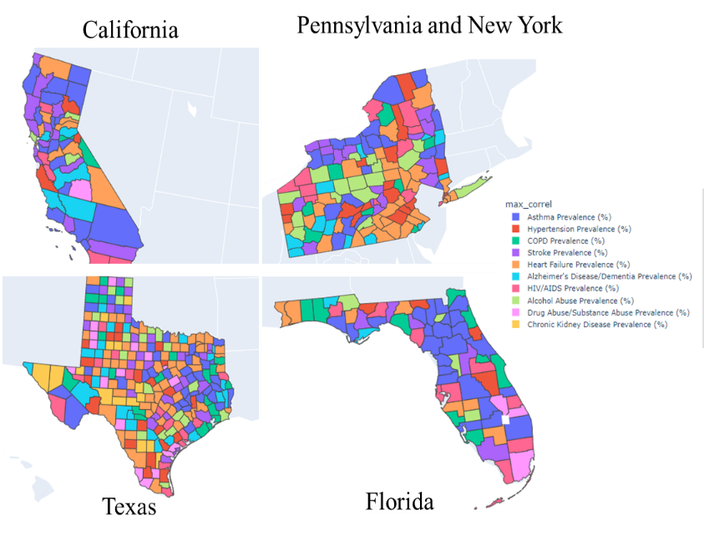

Fig 6. Mapping of maximum correlated diseases w.r.t food insecurity

# conclusions

In this paper, we have explored the hypothesis that food insecurity is affected by chronic diseases. A population affected by a chronic disease has to use all their resources on medical expenditures and also may have a physical limitation leading to high food insecurity. To prove this we predicted the food insecurity rates at the county level using health and county data and got an RMSE of 0.015. This can help accurately predict food insecurity given health data. Additionally, we divided the counties into 7 levels and predicted the levels with an accuracy of 90% across the USA. These food insecurity levels can help identify critical counties and resources can be used to help those counties. To further strengthen this point we mapped maximum correlated variables against food insecurity rates in 5 population-high states. The mapping shows that neighboring counties regularly suffer from the same disease. Hence one can solve the food insecurity of a cluster of neighboring counties by identifying the disease they are suffering from. For future research, we can explore more historical data to strengthen our understanding of health metrics and food insecurity. With high temporal data, we might be able to use deep neural networks to predict food insecurities in the future.

##### appendix

Data variables

* DATA 1: children’s dataset

|  |  |
| --- | --- |
| **Variable** | **Description** |
| YEAR | Discrete. Values from 2016 to 2020 |
| A1_AGE | Continuous. Average age of primary parent/caregiver by state. |
| A2_AGE | Continuous. Average age of second parent/caregiver by state. |
| ACE | % by state of children having an adverse childhood experience (parents divorced, any in jail, abuse or domestic violence, etc. Calculated from binary Y/N variable). |
| FOODASIST | % by state receiving food assistance (calculated from binary Y/N variable) |
| ANXIETY | % of children having anxiety condition (calculated from binary Y/N variable) |
| DEPRESSION | % of children having depression (calculated from binary Y/N variable). |

* DATA 2: adults’ dataset

|  |  |
| --- | --- |
| **Variable** | **Description** |
| Cost Per Meal | Continuous. Average amount spent per week by food secure individuals divided into 21 (3 meals per day, seven days a week). |
| Arthritis Prevalence (%) | % of adults with arthritis prevalence, at state and county level. |
| COPD Prevalence (%) | % of adults suffering from chronic obstructive pulmonary disease, at state and county level. |
| Drug Abuse/Substance Abuse Prevalence (%) | % of adults having drug or any other substance abuse, at state and county level. |

##### References

1. C. Gundersen and H. K. Seligman, “Food insecurity and health outcomes,” *Econ. Voice*, vol. 14, no. 1, 2017, doi: 10.1515/ev-2017-0004.
2. J. Beaulac, E. Kristjansson, and S. Cummins, “A systematic review of food deserts, 1966-2007,” *Prev. Chronic Dis.*, vol. 6, no. 3, 2009.
3. C. Bazerghi, F. H. McKay, and M. Dunn, “The Role of Food Banks in Addressing Food Insecurity: A Systematic Review,” *J. Community Health*, vol. 41, no. 4, pp. 732–740, 2016, doi: 10.1007/s10900-015-0147-5.
4. P. Baiden, C. A. Labrenz, S. Thrasher, G. Asiedua- Baiden, and B. Harerimana, “Adverse childhood experiences and household food insecurity among children aged 0-5 years in the USA,” *Public Health Nutr.*, vol. 24, no. 8, pp. 2123– 2131, 2021, doi: 10.1017/S1368980020002761.
5. M. M. C. Thomas, D. P. Miller, and T. W. Morrissey, “Food insecurity and child health,” *Pediatrics*, vol. 144, no. 4, 2019, doi: 10.1542/peds.2019-0397.
6. D. B. Jackson, M. Chilton, K. R. Johnson, and M. G. Vaughn, “Adverse Childhood Experiences and Household Food Insecurity: Findings From the 2016 National Survey of Children’s Health,” *Am. J. Prev. Med.*, vol. 57, no. 5, pp. 667– 674, 2019, doi: 10.1016/j.amepre.2019.06.004.
7. C. R. Drennen *et al.*, “Food insecurity, health, and development in children under age four years,” *Pediatrics*, vol. 144, no. 4, 2019, doi: 10.1542/peds.2019-0824.
8. J. Jih, I. Stijacic-Cenzer, H. K. Seligman, W. J. Boscardin, T. T. Nguyen, and C. S. Ritchie, “Chronic disease burden predicts food insecurity among older adults,” *Public Health Nutr.*, vol. 21, no. 9, pp. 1737–1742, 2018, doi: 10.1017/S1368980017004062.
9. J. A. Jackson, A. Branscum, A. Tang, and E. Smit, “Food insecurity and physical functioning limitations among older U.S. adults,” *Prev. Med. Reports*, vol. 14, no. February, p. 100829, 2019, doi: 10.1016/j.pmedr.2019.100829.
10. S. L. Goldberg and B. E. Mawn, “Predictors of Food Insecurity among Older Adults in the United States,” *Public Health Nurs.*, vol. 32, no. 5, pp. 397–407, 2015, doi: 10.1111/phn.12173.
11. M. Vilar-Compte, P. Gaitán-Rossi, and R. Pérez- Escamilla, “Food insecurity measurement among older adults: Implications for policy and food security governance,” *Glob. Food Sec.*, vol. 14, no. January, pp. 87–95, 2017, doi: 10.1016/j.gfs.2017.05.003.
12. J. S. Lee, “Food insecurity and healthcare costs: Research strategies using local, state, and national data sources for older adults,” *Adv. Nutr.*, vol. 4, no. 1, pp. 42–50, 2013, doi: 10.3945/an.112.003194.
13. K. L. Hanson and L. M. Connor, “Food insecurity and dietary quality in US adults and children: A systematic review,” *Am. J. Clin. Nutr.*, vol. 100, no. 2, pp. 684–692, 2014, doi: 10.3945/ajcn.114.084525.
14. R. J. Walker *et al.*, “Assessing the relationship between food insecurity and mortality among U.S. adults,” *Ann. Epidemiol.*, vol. 32, pp. 43–48, 2019, doi: 10.1016/j.annepidem.2019.01.014.
15. B. R. Hunt, M. R. Benjamins, S. Khan, and J. L. Hirschtick, “Predictors of Food Insecurity in Selected Chicago Community Areas,” *J. Nutr. Educ. Behav.*, vol. 51, no. 3, pp. 287–299, 2019, doi: 10.1016/j.jneb.2018.08.005.
16. Christian A. Gregory, Alisha Coleman-Jensen. Food Insecurity, Chronic Disease, and Health Among Working-Age Adults, ERR-235, U.S. Department of Agriculture, Economic Research Service, July 2017. www.ers.usda.gov/publications
17. https://www.feedingamerica.org/research/hunger- in-america/datasets
18. https://www.childhealthdata.org/learn-about-the- nsch/NSCH
19. https://www.census.gov/data/datasets/time-series/demo/cps/cps-supp_cps-repwgt/cps-food-security.html
20. <https://map.feedingamerica.org/>
21. https://healthdata.gov/dataset/U-S-Chronic-Disease-Indicators-CDI-/67sp-6x8j/data
22. https://catalog.data.gov/dataset/u-s-chronic-disease- indicators-cdi
23. https://www.cdc.gov/chronicdisease/data/indicators.h tm
24. <https://www.datafiles.samhsa.gov/>
25. https://www.feedingamerica.org/research/map-the-meal-gap/how-we-got-the-map-data
26. https://www.cms.gov/Research-Statistics-Data-and- Systems/Statistics-Trends-and-Reports/Chronic- Conditions/CC_Main
27. https://www.childhealthdata.org/learn-about-the- nsch/nsch-codebooks
28. https://www.childhealthdata.org/learn-about-the- nsch/NSCH
29. https://www.healthcare.gov/glossary/federal- poverty-level- fpl/#:~:text=A%20measure%20of%20income%20issued,and %20Medicaid%20and%20CHIP%20coverage